***Pizza Sales SQL Query***

#1.total revenue earned

select sum(total_price) as total_revenue from ps;

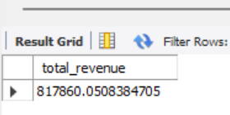

#2. avg order value

select sum(total_price)/count(distinct order_id) as avg_order_value from ps;

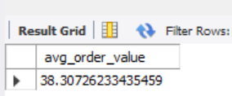

#3.Total pizzas sold

select sum(quantity) as total_pizza_sold from ps;

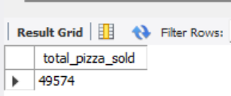

#4.Total order placed

select count(distinct order_id) as total_order_placed from ps;

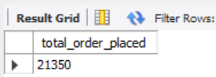

#5.Avg pizza per order

select sum(quantity)/count(distinct order_id)as avg_pizza_perorder from ps;

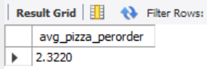

#6.Daily trend for pizza order

SELECT

DAYNAME(STR_TO_DATE(order_date, '%d-%m-%Y')) AS order_day,

COUNT(DISTINCT order_id) AS Total_orders

FROM

ps

GROUP BY

DAYNAME(STR_TO_DATE(order_date, '%d-%m-%Y'))

ORDER BY

CASE

WHEN DAYNAME(STR_TO_DATE(order_date, '%d-%m-%Y')) = 'Monday' THEN 1

WHEN DAYNAME(STR_TO_DATE(order_date, '%d-%m-%Y')) = 'Tuesday' THEN 2

WHEN DAYNAME(STR_TO_DATE(order_date, '%d-%m-%Y')) = 'Wednesday' THEN 3

WHEN DAYNAME(STR_TO_DATE(order_date, '%d-%m-%Y')) = 'Thursday' THEN 4

WHEN DAYNAME(STR_TO_DATE(order_date, '%d-%m-%Y')) = 'Friday' THEN 5

WHEN DAYNAME(STR_TO_DATE(order_date, '%d-%m-%Y')) = 'Saturday' THEN 6

WHEN DAYNAME(STR_TO_DATE(order_date, '%d-%m-%Y')) = 'Sunday' THEN 7

END;

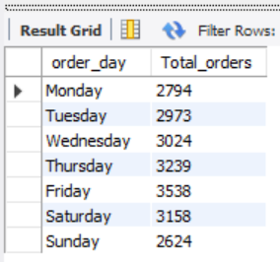

#7.Hourly Trend for pizza order

select hour(order_time) as order_hours,

COUNT(DISTINCT order_id) AS Total_orders

from ps

group by hour(order_time)

order by hour(order_time);

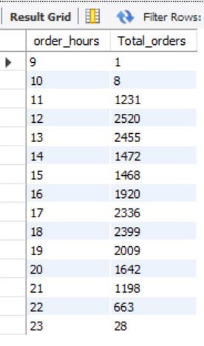

#8.percentage of sale by pizza category

select pizza_category,sum(total_price) as total_sales,

sum(total_price)*100/(select sum(total_price) from ps) as PCT

from ps group by pizza_category;

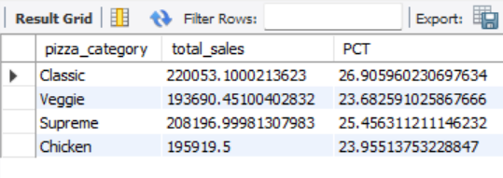

#9. percentage of sale by pizza size

select pizza_size,cast(sum(total_price) as decimal(10,2)) as total_sales,

cast(sum(total_price)*100/(select sum(total_price) from ps)as decimal (10,2)) as PCT

from ps group by pizza_size order by pct desc;

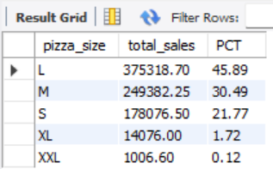

#10.total pizza sold by category

select pizza_category,sum(quantity) as total_pizza_sold from ps

group by pizza_category;

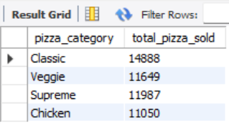

#11. top 5 bestsellers pizza sold

SELECT pizza_name, sum(quantity) as Total_Pizzas_Sold

from ps Group by pizza_name ORDER BY sum(quantity) DESC

LIMIT 5;

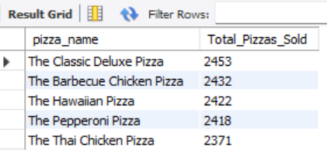

#12.Bottom 5 pizza sold

SELECT pizza_name, sum(quantity) as Total_Pizzas_Sold

from ps Group by pizza_name ORDER BY sum(quantity) asc

limit 5;

